**September 12, 2018**

Dear Parents/Guardians,

At Kennesaw Charter, students in the 4th Grade will take part in completing a Quarterly Science Project. This is an exciting event that encourages students to think like young scientists, engineers, mathematicians, and/or technologists. During the next few weeks your child will be designing a project that uses the scientific method to solve a problem. We hope you agree that the educational benefits are numerous, as students develop skills in writing, oral presentation, creative thinking, and problem solving. **All students in the 4th Grade are required to complete a science project. Students may work in groups of up to three people (which is highly encouraged). Each component of the science project will count towards a test/project grade in science.**

Attached, you will find a description of the components that must be included on the Final Science Project display. In order to insure that our students will be successful with this project, he/she will record their information in their **Science Investigation Journal** and submit their journal on the correct due date to their teacher for approval. If a section is not approved, the student will need to make the necessary changes and re-submit it. **Please note the journal is for planning purposes and will not be part of the final project.** **The pages of your child’s Science Investigation Journal are not to be used on the final display board. The Science Investigation Journal is a way for your child’s teacher to keep track of your child’s progress and as a resource for you and your student during their science investigation**

If you have any questions, please contact me at the school or at 678-290-9628 Ext. 298. Thank you in advance for your support and time.

Parent Signature ___________________________­­______________________________

Student’s name ___________________________________________________________

**Important Dates**

**Science Project Timeline**

|  |  |  |  |
| --- | --- | --- | --- |
|  | **DUE DATE** | **ASSIGNMENT (S)** | Check off when completed OR GRADED |
| **Send out Packets** | Wednesday  9-12-2018 | DATES & TASKS ARE SUBJECT TO CHANGE ACCORDING TO TEACHER |  |
| **September** | Friday  9-14-2018 | **CHOOSE YOUR TOPIC**  Earth, Life, Physical  Turn in parent signature forms to your science teacher |  |
| **September** | Monday  9-17-2018 | Write question/ Hypothesis |  |
| **September** | Thursday  9-20-2018 | Write a Research Plan  **Problem(Question)**  **Hypothesis**  **Materials**  **Procedures** |  |
| **September- October** | 9-21-2018 to  10-03-2018 | You should be working on your experiment.  Ask teacher for guidance if needed.  ***INCLUDES FALL BREAK*** |  |
|  | Thursday  10-03-2018  **DUE DATE** | **SCIENCE PROJECT DUE**  **(Research Paper, Folder Display, Journal)** |  |
| **October** | 10-4-2018 to 10-10-2018 | Students will transfer projects to file folders and start presenting in class  ***STUDENTS WILL PRESENT PROJECTS TO CLASS*** |  |

**j0233971j0233971**

**Parts of the Project**

***The following section gives a brief description of each part that needs to be completed when conducting your science investigation. Please refer to your Science Investigation Journal for more detailed instructions.***

**Question:** the question should run an experiment in which something is modified and the result can be recorded.

*Example: Could the amount of sunlight affect the growth of a plant?*

**Hypothesis** (prediction): A prediction is a tentative answer to a question that is investigated. The prediction forms a reasonable calculation about the result of the experiment and proposes a possible reason for your results. The prediction must be based on previous knowledge, observations or investigations and it’s checked to see if it’s found to be true or false during the investigation. Scientists use the word “Hypothesis” to refer to a prediction.

*Example: if a plant is given sunlight and another plant is not given sunlight,*

***THEN*** *the plant that doesn’t receive sunlight will not grow as tall* ***BECAUSE*** *it will not have the* sufficient energy to do so.

**Materials:** List the materials that you have used in your investigation.

**Variables:** what is changing?

**Procedure:** The procedure includes all the steps that were followed to organize and recollect the data. The procedure is written in a clear and sequential form, so that other people can follow these steps for the experiment. Number each step and clearly state how you went about conducting your experiment.

**Data:** Graphs, tables, and registry of notes, pictures and or drawings must be used to explain the results to the reader. Every science fair project must display data in the form of a graph or table.

**Conclusion:** The results of the experiment include the means taken, and the observations realized. This must include a written explanation of the results, the data that was observed and the media that was used for the experiment. Use the following phrases to write your conclusion:

**Research Paper:** Each student in 4th grade is required to complete a research paper that gives background information on their topic. Please use your Science Investigation Journal to assist in completing your research paper. **Every student in 4TH grade must complete a research paper.**

**Sample Science Project**

**Students will be provided two file folders to create a mini science board. If student moves on to the KCSMA Science Fair then a standard science board will be required.**

* Your display must include everything required. It must be organized in the correct order on the board. It must be neat, attractive, and easy to understand. Pictures and drawings make it more interesting. A chart or graph is highly recommended.
* Your display board must be sturdy enough to stand up by itself. It must fit on a table.
* There must be no identifying information on the front of the display. Your name, your teacher’s name, your school’s name, and pictures that show faces cannot be on the front of your display. **Write ALL IDENTIFYING INFORMATION on the BACK** of your display or attach a card at the bottom back with the following information: Teacher name, Student name, Grade level, Title
* The board should be organized like the following drawing.

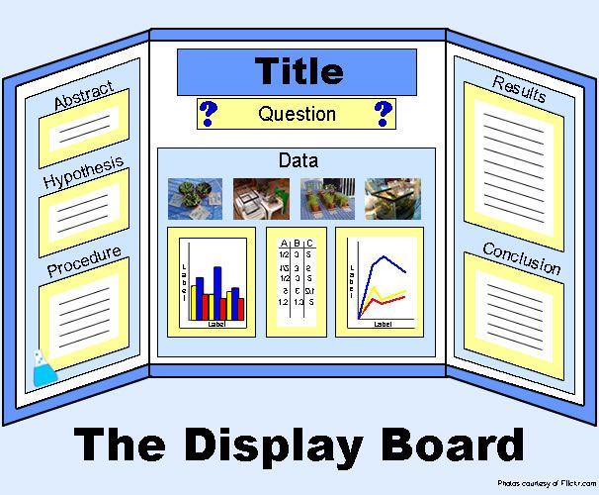

Science Investigation Journal (Page 1)

_________________________________________________________________________________________

_________________________________________________________________________________________

_________________________________________________________________________________________

Teacher Approval _____________________________________

Teacher Comments: ______________________________________________________________________

_________________________________________________________________________________________

_________________________________________________________________________________________

**Hypothesis: (Prediction**) What do you think will happen? _________________________________________________________________________________________

_________________________________________________________________________________________

_________________________________________________________________________________________

**Materials:** What materials do you need in order to do this experiment?

_________________________________________________________________________________________

_________________________________________________________________________________________

_________________________________________________________________________________________

_________________________________________________________________________________________

**Research:** What other information did you find about your topic?

_________________________________________________________________________________________

_________________________________________________________________________________________

_________________________________________________________________________________________

Science Investigation Journal (Page 2)

**Procedure:** What steps will you follow to complete this experiment?

_________________________________________________________________________________________

_________________________________________________________________________________________

_________________________________________________________________________________________

_________________________________________________________________________________________

_________________________________________________________________________________________

_________________________________________________________________________________________

_________________________________________________________________________________________

________________________________________________________________________

**Observations: (Analysis)** What happened during your experiment? What data (information) did you collect? (chart or table)  
_________________________________________________________________________________________

_________________________________________________________________________________________

_________________________________________________________________________________________

__________________________________________

**Conclusion**: Was your hypothesis correct? What did you learn from this experiment? What would you do differently next time? _________________________________________________________________________________________

_________________________________________________________________________________________

_________________________________________________________________________________________

_____________________________________________________

***Science Project Rules***

1. Most of the work on your science project is to be done at home. Some time may be given to classes to complete portions of the project, i.e. the written report, in class. This will be decided by each classroom teacher. Students may seek advice from teachers during designated times, but work on the project itself should be done outside school time.
2. Use of live animals is discouraged. Any exceptions must be approved by the classroom teacher. Displays cannot contain any dead animals.
3. The science project should be made into a display with labels, lettering, pictures and/or an explanation of the project. Make the display attractive, interesting and easy to understand.
4. Projects should be done primarily by the student. Adult assistance is permitted and encouraged as mentioned earlier. Please remember this is your student’s project and it should be your student’s work.
5. There must be no identifying information on the front of the display. Your name, your teacher’s name and pictures that show faces cannot be on the front of your display. **Write ALL IDENTIFYING INFORMATION on the BACK of the board**
6. Any questions should be directed to the classroom teacher.